1763. Longest Nice Substring

class Solution {

public:

string longestNiceSubstring(string s) {

unordered_set<char> missing;

for (char c : s) {

if (islower(c)) missing.insert(toupper(c));

else missing.insert(tolower(c));

}

for (int i = 0; i < s.size(); i++) {

if (missing.count(s[i])) {

continue;

}

string s1 = longestNiceSubstring(s.substr(0, i));

string s2 = longestNiceSubstring(s.substr(i + 1));

return s1.size() >= s2.size() ? s1 : s2;

}

return s;

}

};

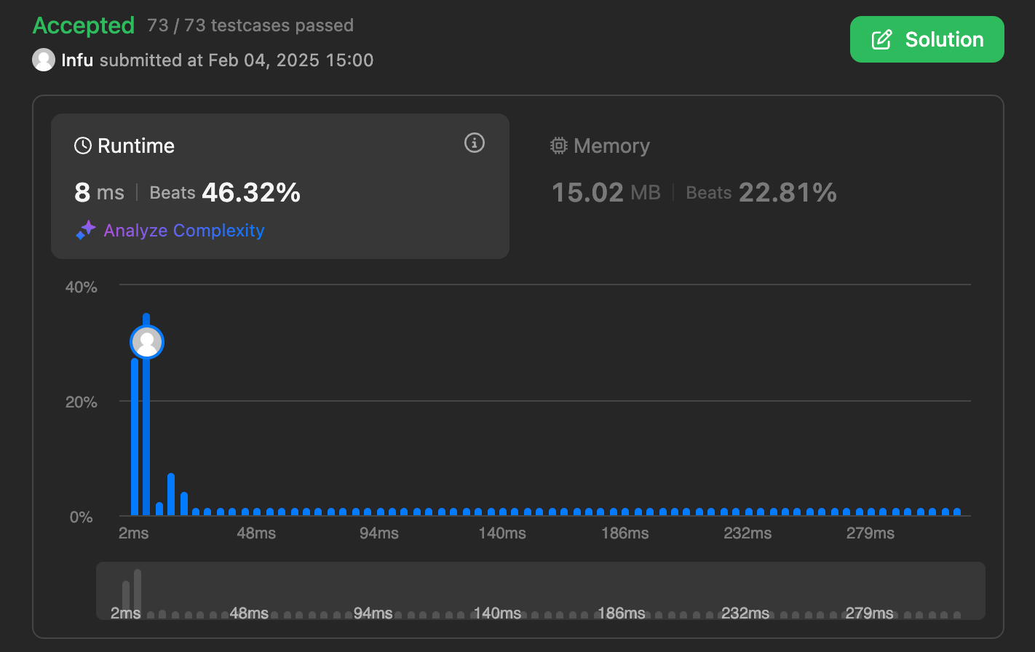

190. Reverse Bits

class Solution {

public:

uint32_t reverseBits(uint32_t n)

{

string bits = bitset<32>(n).to_string();

reverse(bits.begin(), bits.end());

int ans = stoll(bits, NULL, 2);

return ans;

}

};

ˇ

191. Number of 1 Bits

class Solution {

public:

int hammingWeight(int n) {

stack<int> s;

while(n){

s.push(n % 2);

n = n / 2;

}

int count = 0;

while(!s.empty()){

if(s.top() == 1) count++;

s.pop();

}

return count;

}

};



53. Maximum Subarray

class Solution {

public:

int maxSubArray(vector<int>& arr) {

long long maxi = LONG_MIN; // maximum sum

long long sum = 0;

int n = arr.size();

for (int i = 0; i < n; i++) {

sum += arr[i];

if (sum > maxi) {

maxi = sum;

}

if (sum < 0) {

sum = 0;

}

}

return maxi;

}

};

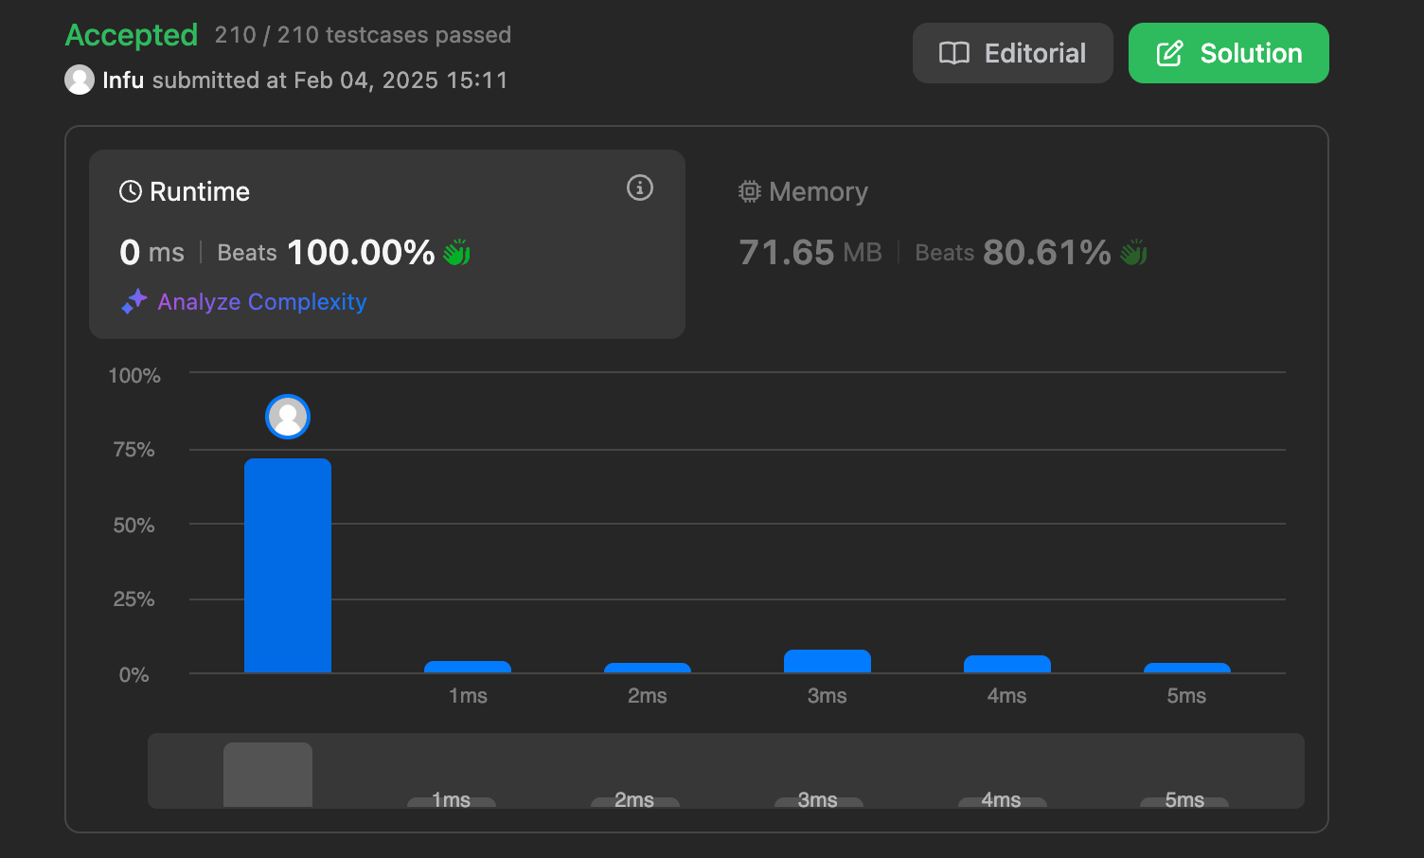

240. Search a 2D Matrix II

class Solution {

public:

bool searchMatrix(vector<vector<int>>& matrix, int target) {

int cols = matrix[0].size() - 1;

int n = matrix.size() - 1;

int rows = 0;

while(rows <= n && cols >= 0){

int toCompare = matrix[rows][cols];

if(toCompare > target){

cols--;

}else if(toCompare < target){

rows++;

}else{

return true;

}

}

return false;

}

};

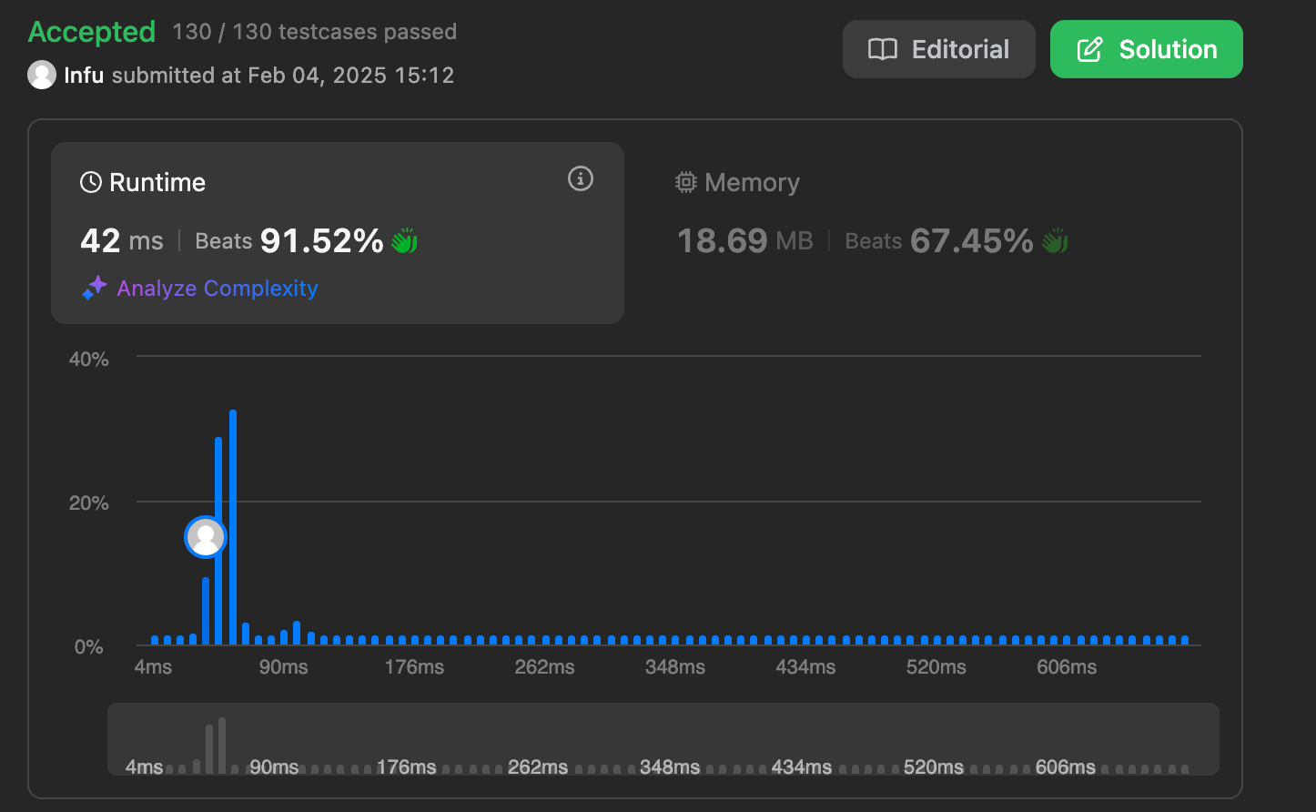

372. Super Pow

class Solution {

public:

int pow(int a, int b){

if(b==0) return 1;

int temp=pow(a,b/2);

if(b%2==0) return ((temp%1337)*temp%1337)%1337;

else return (a%1337*((temp%1337*temp%1337)%1337))%1337;

}

int superPow(int a, vector<int>& b) {

if(b.size()==0) return 1;

int x=b.back(); b.pop_back();

return pow(superPow(a, b), 10) * pow(a, x) % 1337;

}

};

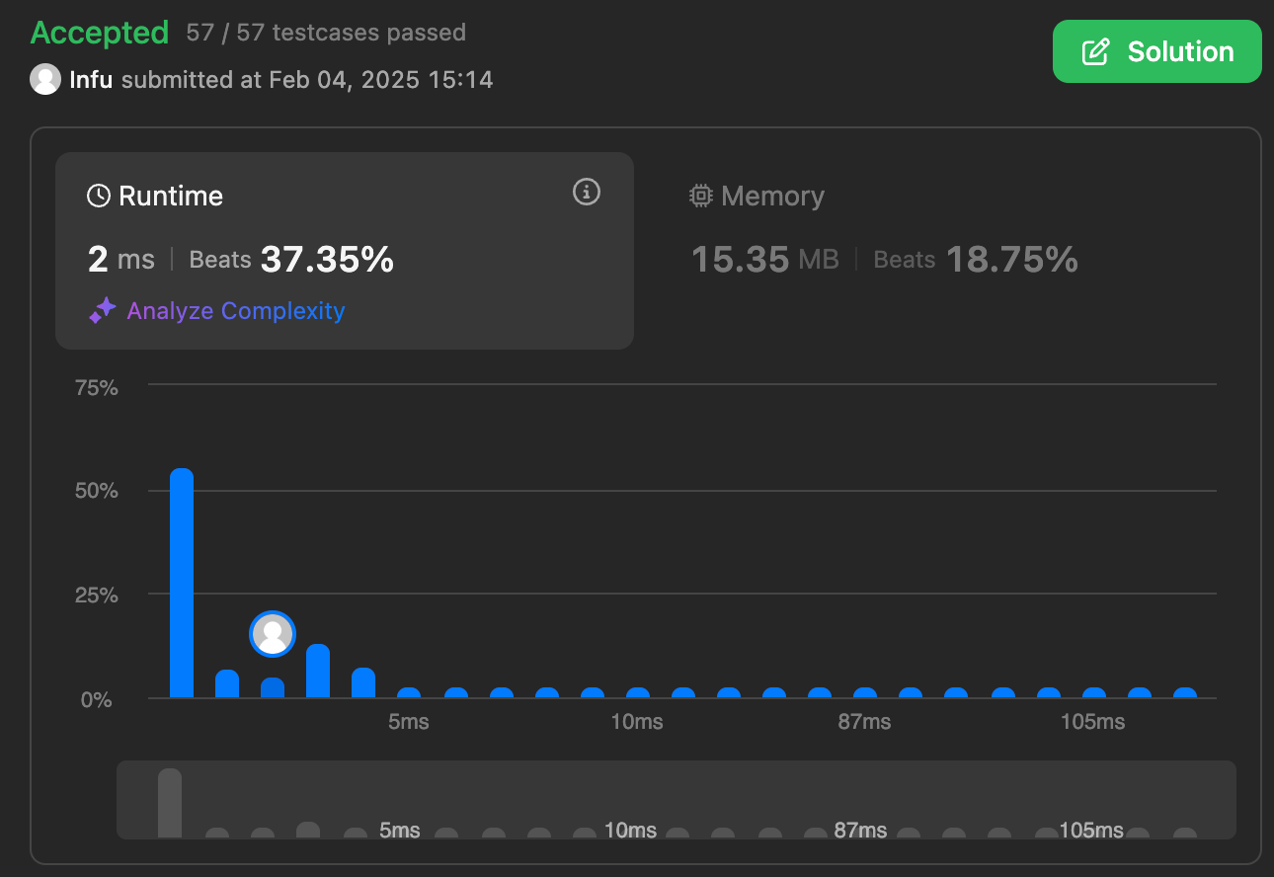

932. Beautiful Array

class Solution {

public:

vector<int> beautifulArray(int n) {

if (n==1) return {1};

vector<int> arr = beautifulArray(n-1);

vector<int> res;

for (auto i: arr)

if (2*i - 1 <= n)

res.push_back(2*i-1);

for (auto i: arr)

if (2*i <= n)

res.push_back(2*i);

return res;

}

};



218. The Skyline Problem

class Solution {

public:

vector<vector<int>> getSkyline(vector<vector<int>>& b) {

priority_queue<vector<int>> live;

int n=b.size();

int cur=0;

vector<vector<int>> ans;

while(cur<n || !live.empty()){

int cur_x=live.empty()?b[cur][0]:live.top()[1];

if(cur>=n || b[cur][0]>cur_x){

while(!live.empty() && (live.top()[1]<=cur_x)){

live.pop();

}

}

else{

cur_x=b[cur][0];

while(cur<n && cur_x==b[cur][0]){

live.push({b[cur][2],b[cur][1]});

cur++;

}

}

int cur_h=live.empty()?0:live.top()[0];

if(ans.empty() || ans[ans.size()-1][1]!=cur_h){

ans.push_back({cur_x,cur_h});

}

}

return ans;

}

};

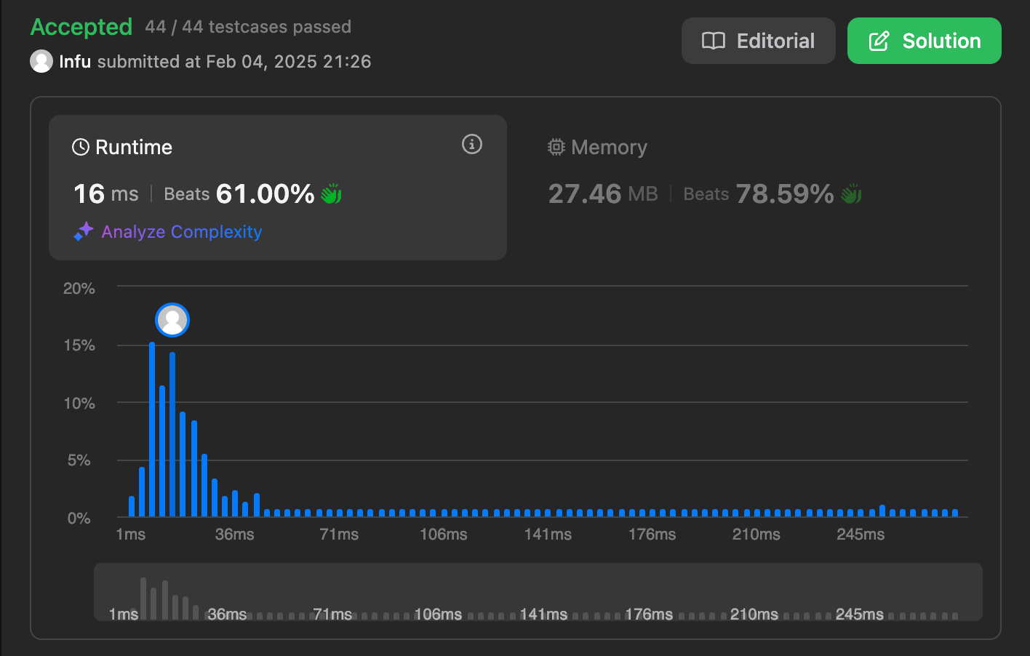

493. Reverse Pairs

class Solution {

private:

void merge(vector<int>& nums, int low, int mid, int high, int& reversePairsCount){

int j = mid+1;

for(int i=low; i<=mid; i++){

while(j<=high && nums[i] > 2*(long long)nums[j]){

j++;

}

reversePairsCount += j-(mid+1);

}

int size = high-low+1;

vector<int> temp(size, 0);

int left = low, right = mid+1, k=0;

while(left<=mid && right<=high){

if(nums[left] < nums[right]){

temp[k++] = nums[left++];

}

else{

temp[k++] = nums[right++];

}

}

while(left<=mid){

temp[k++] = nums[left++];

}

while(right<=high){

temp[k++] = nums[right++];

}

int m=0;

for(int i=low; i<=high; i++){

nums[i] = temp[m++];

}

}

void mergeSort(vector<int>& nums, int low, int high, int& reversePairsCount){

if(low >= high){

return;

}

int mid = (low + high) >> 1;

mergeSort(nums, low, mid, reversePairsCount);

mergeSort(nums, mid+1, high, reversePairsCount);

merge(nums, low, mid, high, reversePairsCount);

}

public:

int reversePairs(vector<int>& nums) {

int reversePairsCount = 0;

mergeSort(nums, 0, nums.size()-1, reversePairsCount);

return reversePairsCount;

}

};

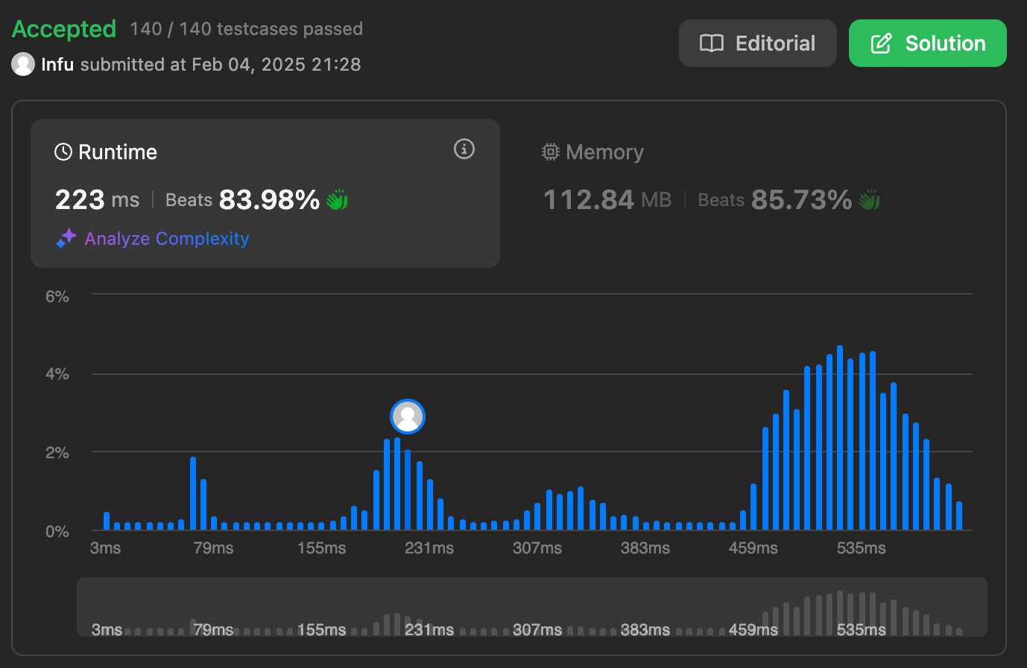

2407. Longest Increasing Subsequence II

const int N = 1e5+1;

class Solution {

public:

int lengthOfLIS(vector<int>& nums, int k) {

int n = nums.size();

int t[2*N + 2]; memset(t, 0, sizeof(t));

auto upd = [&](int p, int v) {

p += N;

t[p] = v;

for(; p > 1; p >>= 1) t[p>>1] = max(t[p], t[p^1]);

};

auto qry = [&](int l, int r) {

l+=N, r+=N;

int ret = 0;

for(; l<r; l>>=1, r>>=1) {

if (l&1) ret = max(ret, t[l++]);

if (r&1) ret = max(ret, t[--r]);

}

return ret;

};

//upd(nums[0], 1);

for (int i=0; i<n; ++i) {

int curr = nums[i];

int best = 1 + qry(max(0, curr - k), curr);

upd(curr, best);

}

int ans = qry(0, N+1);

return ans;

}

};

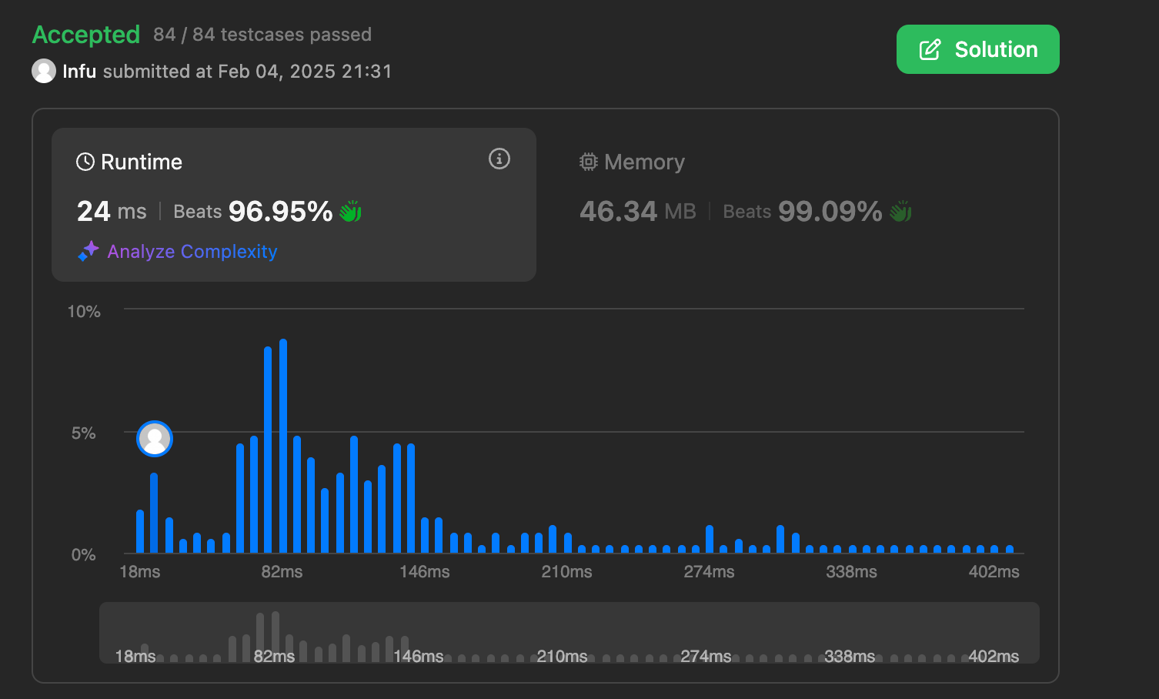

88. Merge Sorted Array

class Solution {

public:

void merge(vector<int>& nums1, int m, vector<int>& nums2, int n) {

int i = m-1;

int j = n-1;

int k = m+n-1;

while(i>=0 && j>=0){

if(nums1[i] > nums2[j]){

nums1[k] = nums1[i];

i--; k--;

}

else{

nums1[k] = nums2[j];

j--; k--;

}

}

while(j>=0){

nums1[k] = nums2[j];

j--; k--;

}

}

};



278. First Bad Version

class Solution {

public:

int firstBadVersion(int n) {

int start = 1, end = n;

while(start <= end){

int mid = start + (end - start) / 2; // to avoid overflow

if(isBadVersion(mid)){

end = mid - 1;

}else{

start = mid + 1;

}

}

return start;

}

};



75. Sort Colors

class Solution {

public:

void sortColors(vector<int>& arr) {

int low = 0, mid = 0, high = arr.size() - 1; // 3 pointers

while (mid <= high) {

if (arr[mid] == 0) {

swap(arr[low], arr[mid]);

low++;

mid++;

}

else if (arr[mid] == 1) {

mid++;

}

else {

swap(arr[mid], arr[high]);

high--;

}

}

}

};

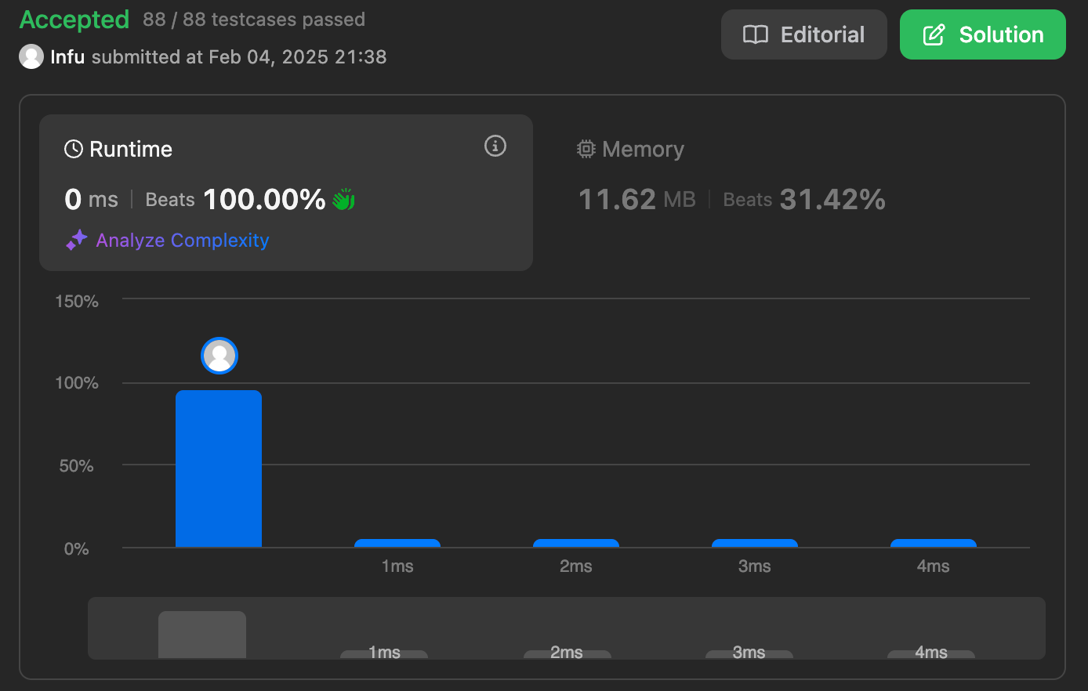

347. Top K Frequent Elements

class Solution {

public:

vector<int> topKFrequent(vector<int>& nums, int k) {

unordered_map<int,int> map;

for(int num : nums){

map[num]++;

}

vector<int> res;

priority_queue<pair<int,int>> pq;

for(auto it = map.begin(); it != map.end(); it++){

pq.push(make_pair(it->second, it->first));

if(pq.size() > (int)map.size() - k){

res.push_back(pq.top().second);

pq.pop();

}

}

return res;

}

};

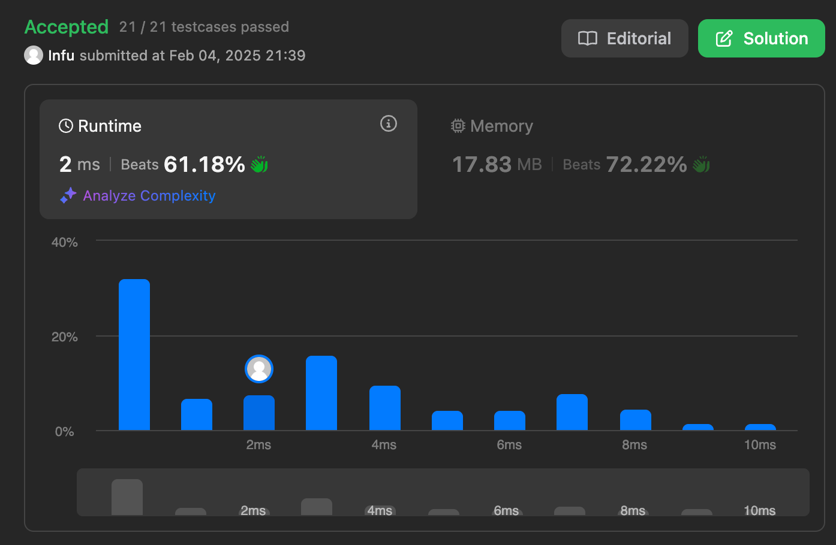

215. Kth Largest Element in an Array

class Solution {

public:

int findKthLargest(vector<int>& nums, int k) {

priority_queue<int, vector<int>, greater<int>> pq;

for (int num : nums) {

pq.push(num);

if (pq.size() > k) {

pq.pop();

}

}

return pq.top();

}

};

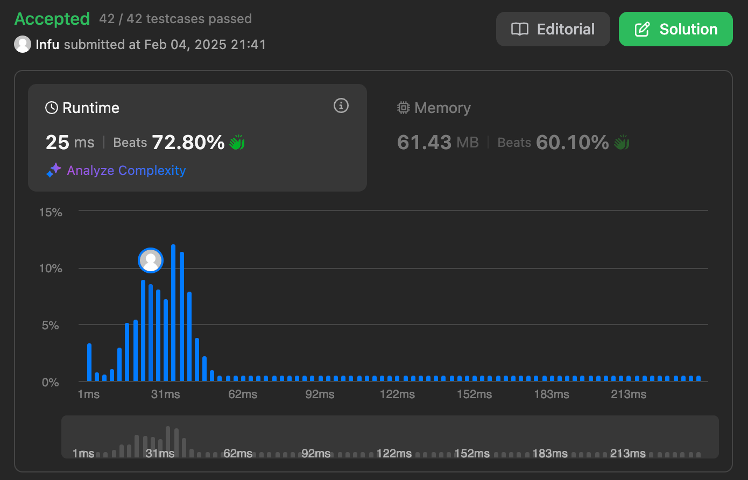

162. Find Peak Element

class Solution {

public:

int findPeakElement(vector<int>& nums) {

int n = nums.size();

int low = 0, high = n - 1;

while (low <= high) {

int mid = low + (high - low) / 2;

if ((mid == 0 || nums[mid] > nums[mid - 1]) &&

(mid == n - 1 || nums[mid] > nums[mid + 1])) {

return mid;

}

if (mid < n - 1 && nums[mid] < nums[mid + 1]) {

low = mid + 1;

} else {

high = mid - 1;

}

}

return -1;

}

};



56. Merge Intervals

class Solution {

public:

vector<vector<int>> merge(vector<vector<int>>& intervals) {

if(intervals.size()==1)

return intervals;

vector<pair<int,int>> p;

for(int i=0;i<intervals.size();i++)

{

p.push_back({intervals[i][0],intervals[i][1]});

}

sort(p.begin(),p.end());

vector<vector<int>> ans;

int f=p[0].first,s=p[0].second;

for(int i=0;i<p.size()-1;i++)

{

vector<int> a(2);

if(s>=p[i+1].first)

{

s=max(s,p[i+1].second);

}

else

{

a[0]=f;

a[1]=s;

f=p[i+1].first;

s=p[i+1].second;

ans.push_back(a);

}

}

int n=intervals.size();

ans.push_back({f,s});

return ans;

}

};

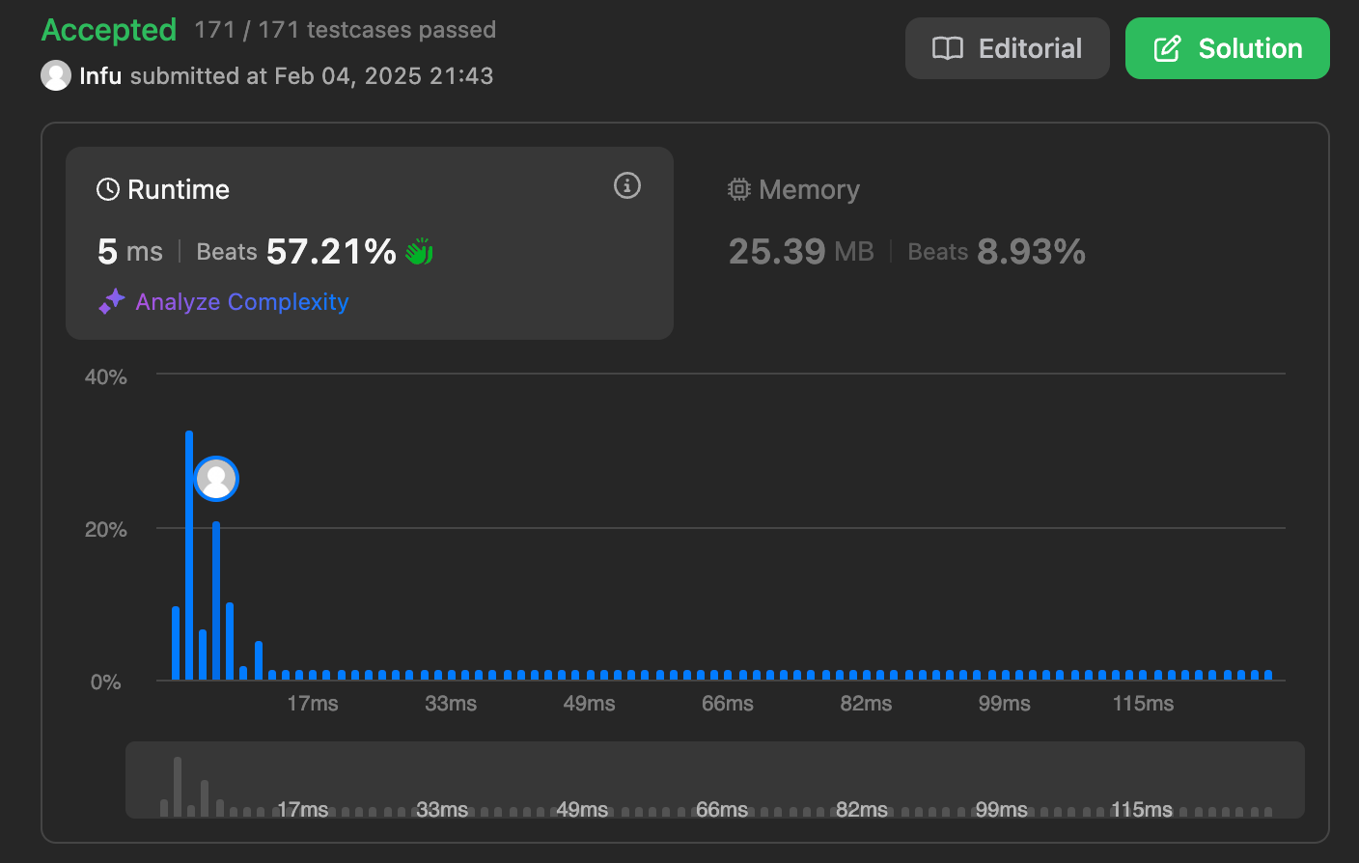

33. Search in Rotated Sorted Array

class Solution {

public:

int search(vector<int>& nums, int x) {

int low = 0;

int high = nums.size() - 1;

while (low <= high) {

int mid = low + (high - low) / 2;

if (nums[mid] == x)

return mid;

// Check if the left half is sorted

if (nums[low] <= nums[mid]) {

// Check if x lies in the sorted left half

if (x >= nums[low] && x < nums[mid])

high = mid - 1;

else

low = mid + 1;

}

// Otherwise, the right half must be sorted

else {

// Check if x lies in the sorted right half

if (x > nums[mid] && x <= nums[high])

low = mid + 1;

else

high = mid - 1;

}

}

return -1;

}

};



240. Search a 2D Matrix II

class Solution {

public:

bool searchMatrix(vector<vector<int>>& matrix, int target) {

int cols = matrix[0].size() - 1;

int n = matrix.size() - 1;

int rows = 0;

while(rows <= n && cols >= 0){

int toCompare = matrix[rows][cols];

if(toCompare > target){

cols--;

}else if(toCompare < target){

rows++;

}else{

return true;

}

}

return false;

}

};

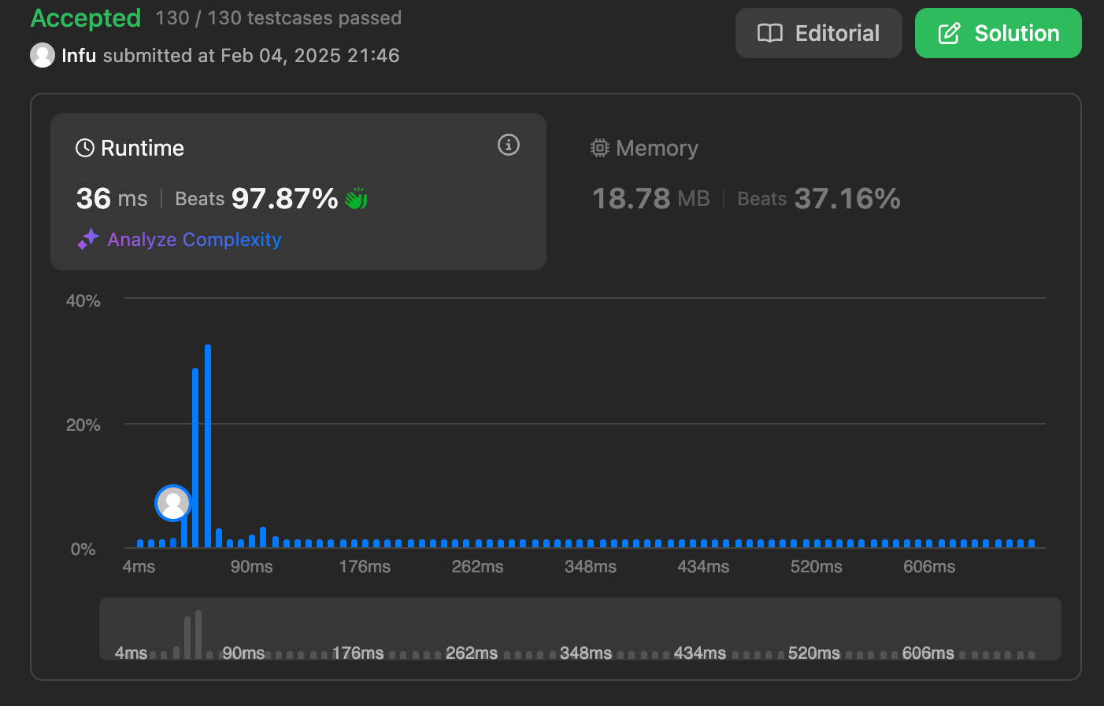

324. Wiggle Sort II

class Solution {

public:

void wiggleSort(vector<int>& nums) {

int maxx = *max_element(nums.begin(),nums.end());

vector<int> sortArray(maxx+1,0);

for( int i=0; i<nums.size(); i++ )

sortArray[nums[i]]++;

int j = maxx;

for( int i=1; i<nums.size(); i+=2 )

{

while( sortArray[j] == 0 )

j--;

nums[i] = j;

sortArray[j]--;

}

for( int i=0; i<nums.size(); i+=2 )

{

while( sortArray[j] == 0 )

j--;

nums[i] = j;

sortArray[j]--;

}

}

};



378. Kth Smallest Element in a Sorted Matrix

class Solution {

public:

int kthSmallest(vector<vector<int>>& matrix, int k) {

vector<int> result;

for (const auto& row : matrix) {

for (const auto& element : row)

result.push_back(element);

}

sort(result.begin(), result.end());

int size=result.size();

if(size<k) return -1;

return result[k-1];

}

};

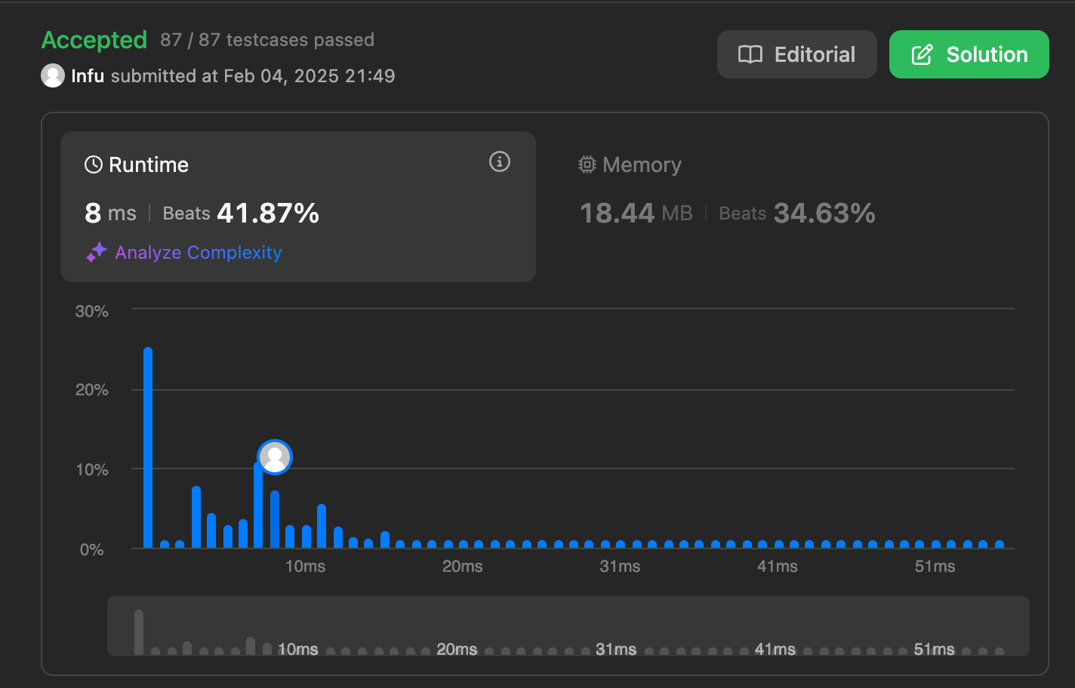

4. Median of Two Sorted Arrays

class Solution {

public:

double findMedianSortedArrays(vector<int>& nums1, vector<int>& nums2) {

vector<int>v;

for(auto num:nums1)

v.push_back(num);

for(auto num:nums2)

v.push_back(num);

sort(v.begin(),v.end());

int n=v.size();

return n%2?v[n/2]:(v[n/2-1]+v[n/2])/2.0;

}

};

